**16-BIT MULTIPLICATION**  
  
  
**EXP NO: 7**  
**AIM:**To write an assembly language program to  
implement 16-bit multiplication using 8085 processor.  
  
**ALGORITHM:**  
  
1)      Load  
the first data in HL pair.

2)      Move  
content of HL pair to stack pointer.  
  
3)      Load  
the second data in HL pair and move it to DE.  
  
4)      Make  
H register as 00H and L register as 00H.  
  
5)      ADD  
HL pair and stack pointer  
  
6)      Check  
for carry if carry increment it by 1 else move to next step.  
  
7)      Then  
move E to A and perform OR operation with accumulator and register D.  
  
8)      The  
value of operation is zero, then store the value else go to step 3.  
  
**PROGRAM:**  
  
         LHLD  
2050  
  
  
         SPHL  
  
  
         LHLD  
2052  
  
  
         XCHG  
  
  
         LXI  
H,0000H  
  
  LXI  
B,0000H  
  
  
          
AGAIN: DAD SP  
  
  
         JNC  
START  
  
  
         INX B  
  
  
         START: DCX D  
  
  
         MOV  
A,E  
  
  
         ORA D  
  
  
         JNZ  
AGAIN  
  
  
         SHLD  
2054  
  
  
         MOV  
L,C  
  
  
         MOV  
H,B  
  
  
         SHLD  
2056  
  
  
         HLT

**INPUT:**

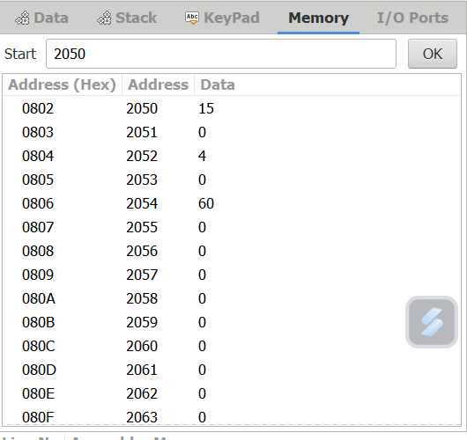  
**OUTPUT:**

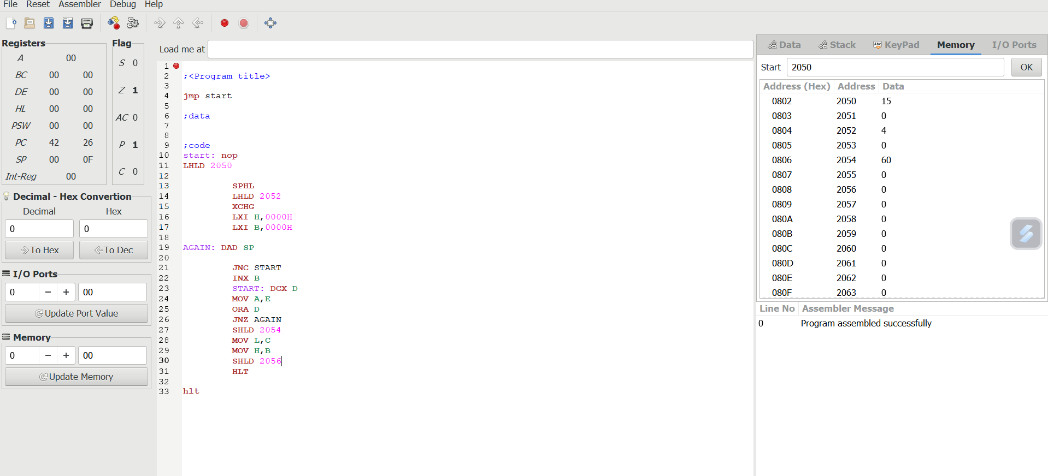

**RESULT:**Thus  
the program was executed successfully using 8085 processor simulator.